# **B1. Software Defined Radio at 5.8 GHz**

This section discusses the SDR part of the project, it implements the radar system in software using the USRP SDR, the flowgraphs were implemented GNU Radio while the processing of the data was done in MATLAB. Figure 2.1 shows the completed hardware.

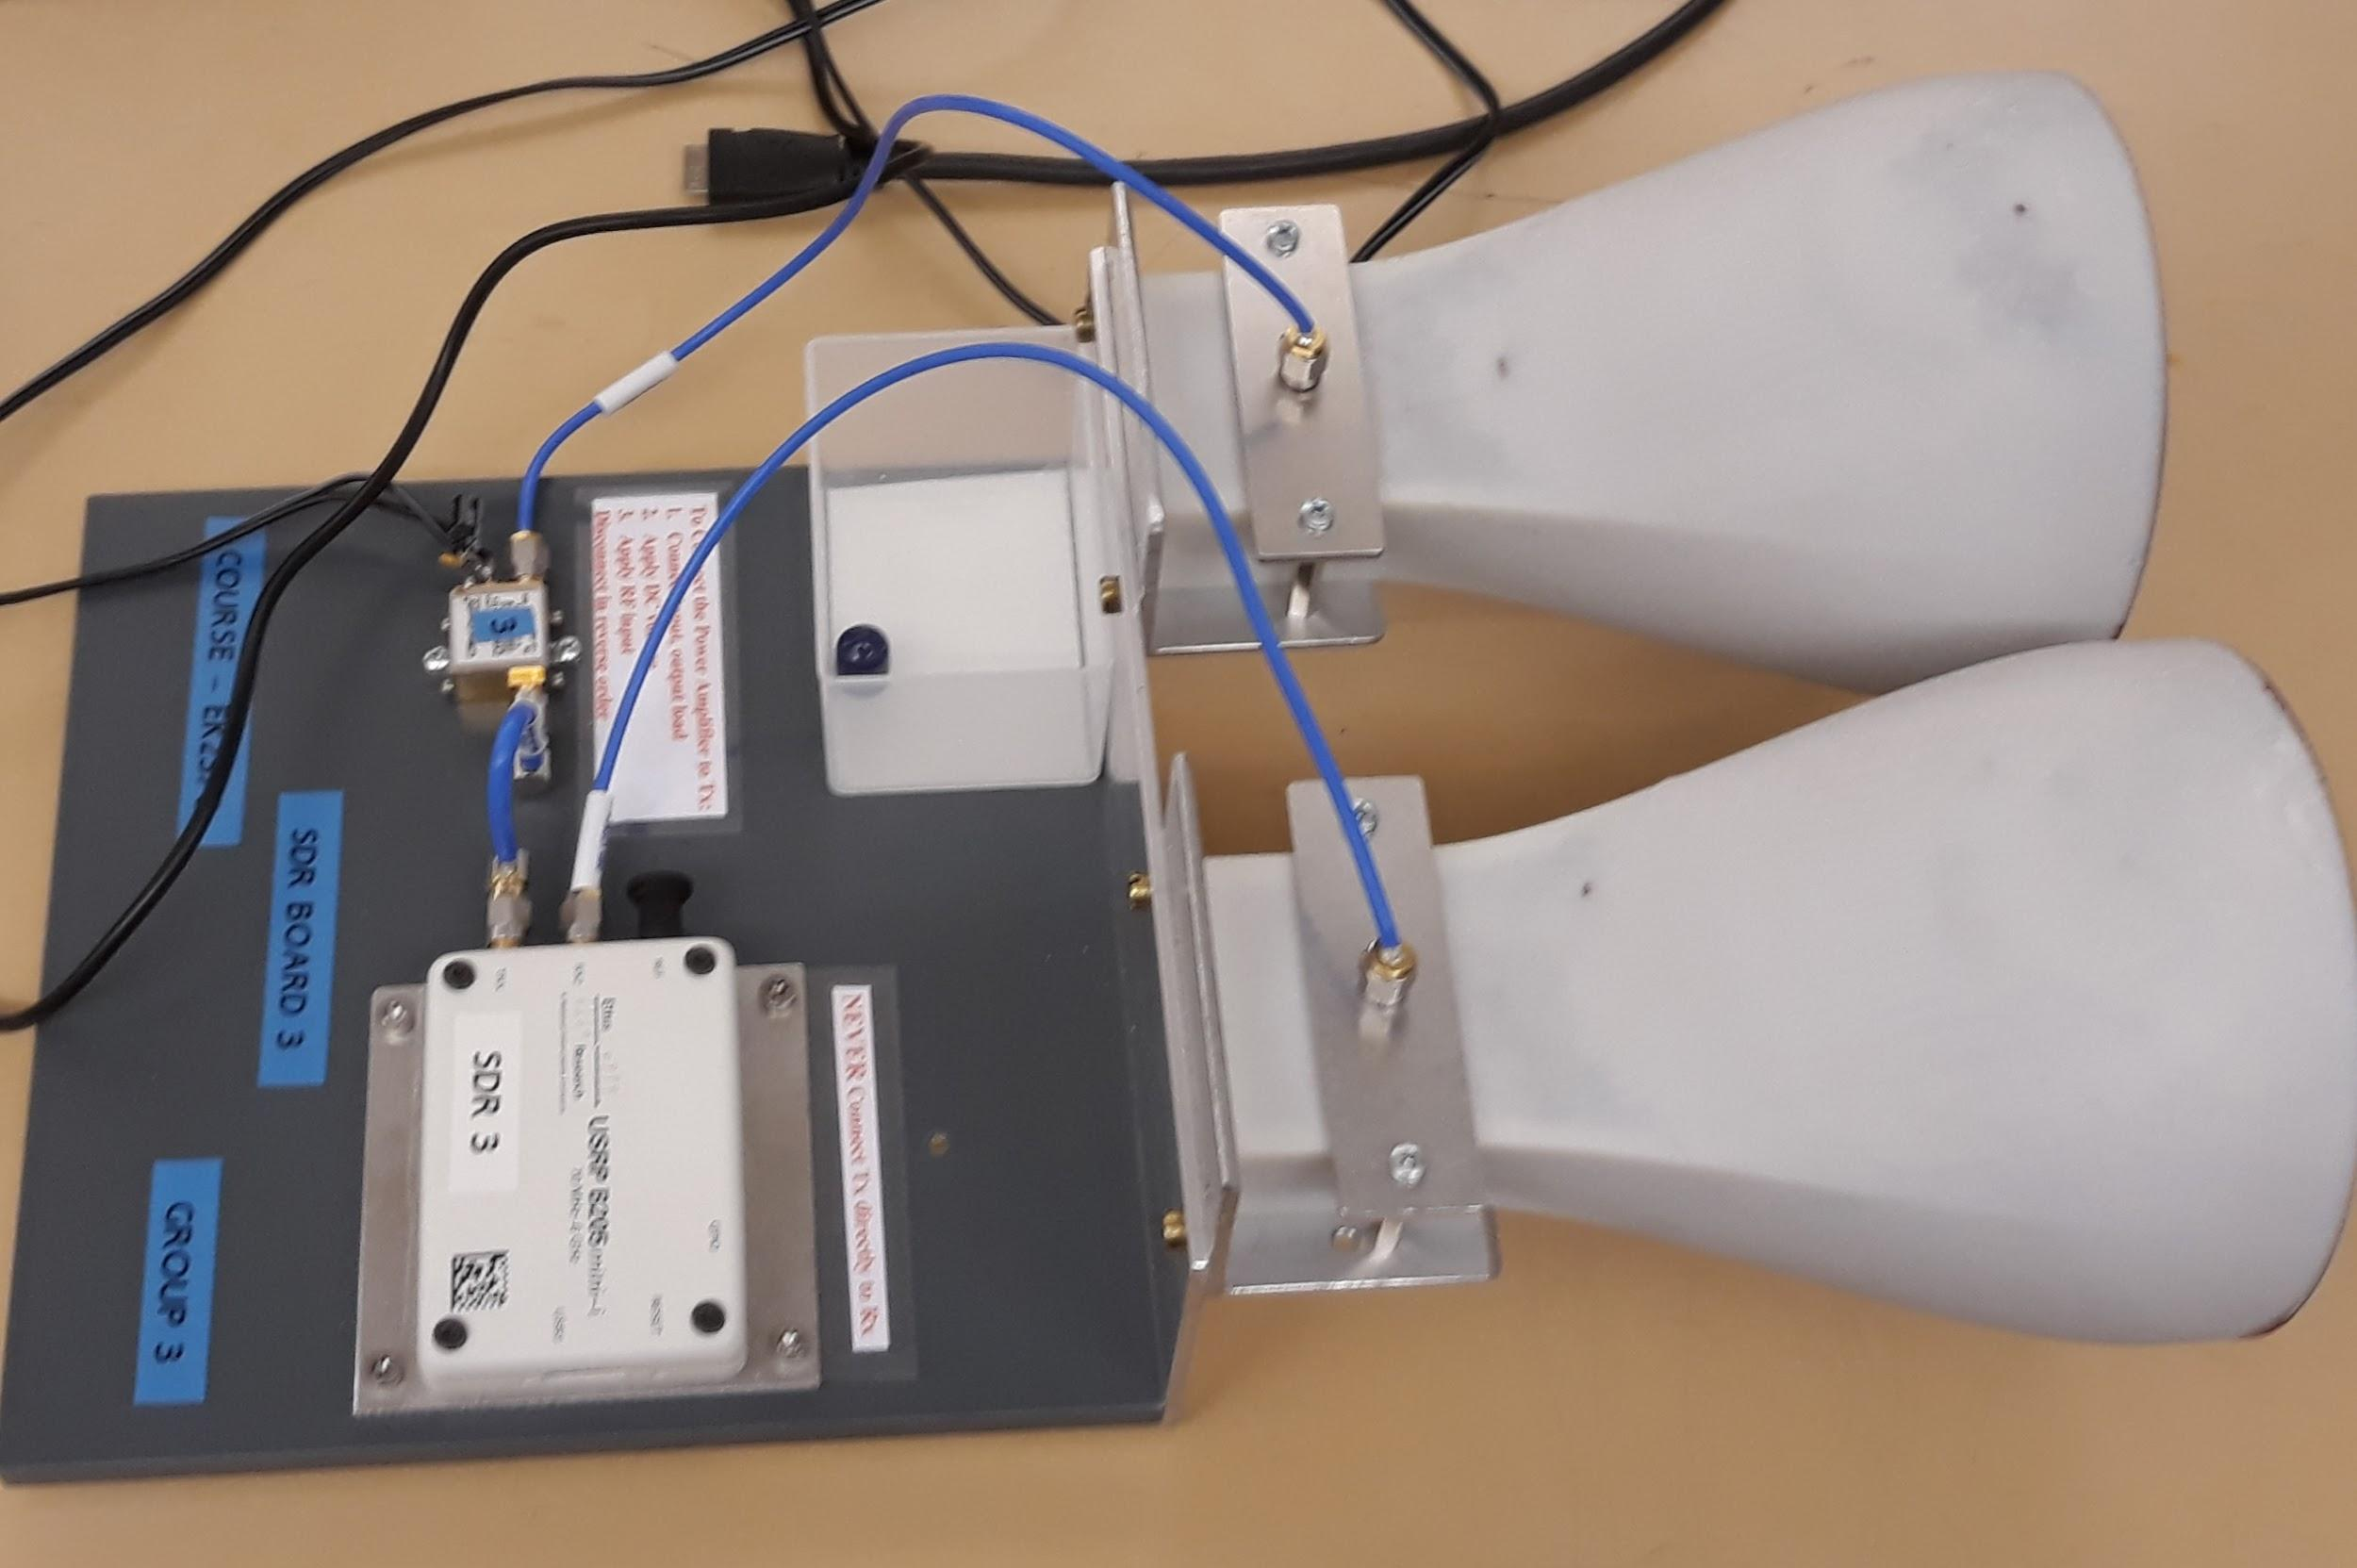

Figure 2.1 SDR radar hardware

## S-Parameters

**S parameter for the Amplifier ;**

**S-parameter for the horn antenna ;**

5.830000000000000E9 (Freq in Hz) -1.815378912740862E1 (s11) 2.289587253927021(dB)

## **Velocity measurements for multiple targets at the same time in the CW mode.**

As shown in the flow graph depicted in figure 2.2, a sine wave of a unit amplitude sampled at 1Mz is transmitted via the **UHD:USRP Sink block.** The sample rate at the transmitter is also set at 1MHz, center frequency at 5.8GHz and an absolute gain of 60dB.

The receiver chain consist of a **UHD:USRP Source** which is set at an absolute gain of 50dB, center frequency of 5.8GHz and also sampled at 1MHz. the Signal is mixed with transmitted signal then it is now pass to it complex-to-floats block before being saved as in sound file using the wav-file-sink block.

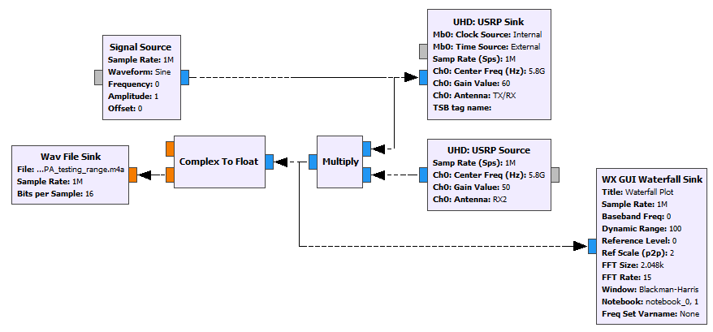

Figure 2.2 CW radar implementation in GNU Radio

The saved wav file is now processed in MATLAB in accordance to algorithm given in the lecture note; in fact, the same code was used here as in the first of the project (using COTS components), only that the center frequency was changed to reflect the frequency used here. The code can be found in the appendix section of the report.

Figure 2.3.1 shows the result of the velocity measurement for a single target while figure 2.3.2 is for double target. Here (figure 2.3.2), one of the targets was running back and fort (completed 6 cycles of this) while the order was walking slowly throughout the test time, this is evident in the readings present around low velocity (at about 1.5 m/s) while the running target had a velocity of about 5m/s. In comparison, the figure 2.3.1 (for single target) only shows a single target running back and fort and completed 3 cycles at a maximum speed of about 6m/s.

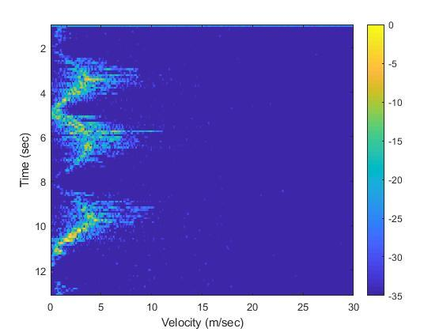

Figure 2.3.1 Result of the CW radar implementation in MATLAB (Single target)

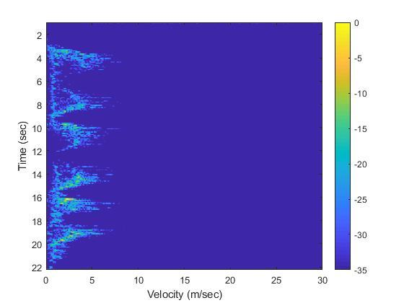

Figure 2.3.2 Result of the CW radar implementation in MATLAB (double targets)

## **Velocity direction detection for a single target in the CW mode using the IQ demodulator of the SDR.**

The figure 2.4 shows the CW radar with IQ demodulator. The basic flowgraph is the same as the normal CW radar only that an extra processing is added before saving the wav file. Of these extra chains is the Add-Constant block. A value of 1.5708 (3.142/2 or pi/2) is added the phase (this is the same as adding 90 degrees) so as to be able to extract the In-phase and quadrature component as evident in the double wav file saved.

It should also be noted that while all other parameter remained the same, the absolute gain of the transmitted signal has been reduced to 40dB (as can be seen in the UHD:USRP Sink block), this is because and external amplifier has been included in the chain and this external amplifier adds a gain of 21dB, so it was necessary to include reduce its effect.

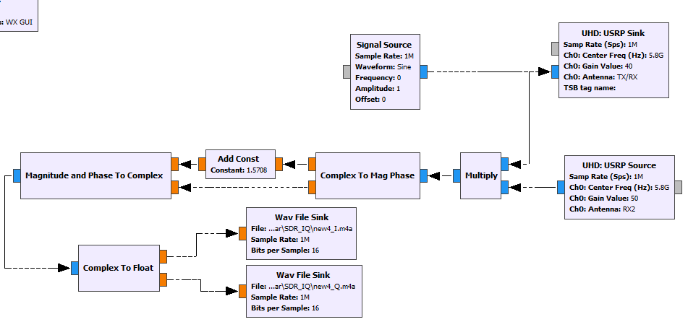

Figure 2.4 CW radar with IQ demodulator

The result of this section in figure 2.5 shows the direction of the velocity; the first one (a part) shows the target as moving towards the observer (our radar) while the second one (b part) shows the target moving away from the observer.

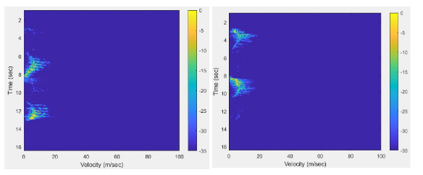

Figure 2.5 CW radar with IQ demodulator result; a-in phase channel, b-quadrature channel

## **Range measurements for multiple targets at the same time in the stepped frequency CW (SFCW) mode**

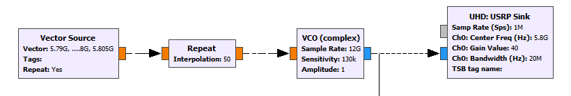

Figure 2.6 flowgraph of the transmitter section of the SFCW for range measurement.

As shown in the figure 2.6, the flowgraph consist of 4 major block; the Vector-source, Repeat, VCO (voltage controlled oscillator) and the USRP Sink block. The sampling rate for the transmitter block was set at 1MHz, with a gain of 40dB (accompanied by the 21dB external amplifier) and a bandwidth of 20MHz(this bandwidth was selected as the USB itself was limited to this bandwidth).

The vector source represents the different step frequencies we expect to have and the interpolation parameter on the repeat block set to 50 shows the duration each of the step frequency should last (in milliseconds). The VCO is set to a unit amplitude and sampling rate of 12GHz, this was chosen as our Nyquist frequency is around 6GHz. Although the sensitivity value was chosen arbitrarily, this value has been shown to work well by some researches[1].

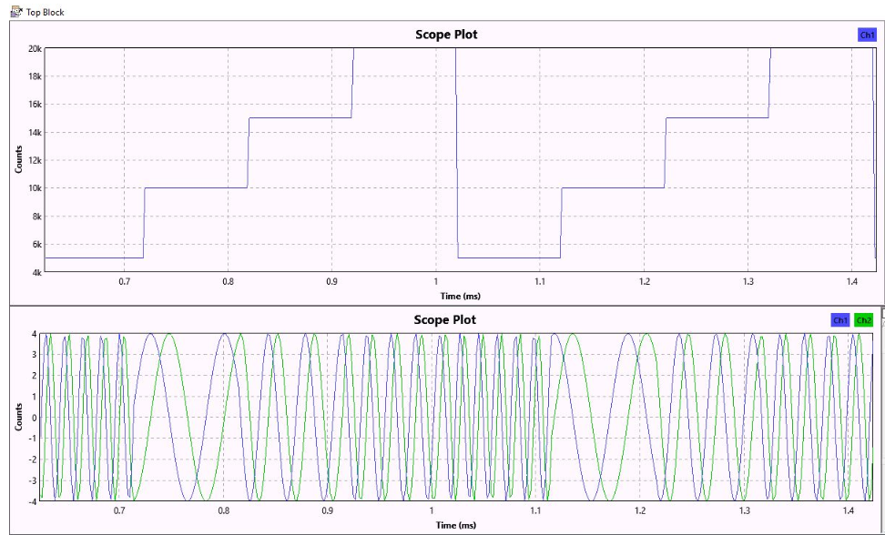

Figure 2.7 VCO input(top) and output(bottom)

The output of the VCO shows the variations in the frequency as the step frequency changes. Looking at the graph (VCO output), it doesn’t seem to totally correspond to the step frequency magnitude as the very first frequency (VCO output) shows highest frequency while the step (VCO input) is at the lowest. This is due to a propagation delay within the VCO block; hence the VCO output came one-clock cycle slower. Keeping this delay in mind, the result shown in figure 2.7 fully shows how the VCO produces a sine wave to be transmitted which is properly modulated by the input step frequency.

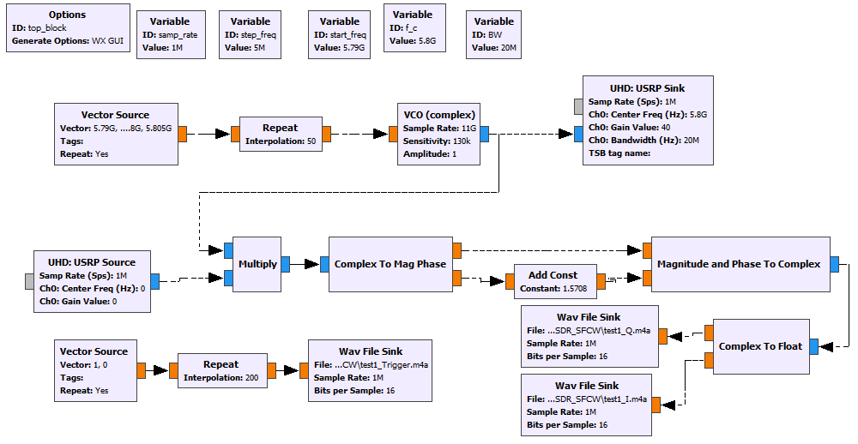

Figure 2.8 Full flow diagram of the SFCW radar with IQ demodulation.

The full flowgraph of the SFCW in figure 2.8 shows the whole transmit and receive chain. An extra independent chain is also depicted in the bottom left corner of the image consisting of the vector-source, Repeat and wav file sink blocks is used to generate a trigger signal that will be used in the processing.

After the whole signal was ran in the GNU Radio application, it seemed to work well and the wav files were saved to be processed in MATLAB. We were unable to complete the processing part of this section, partly due to unavailability of any working algorithm and time constraint in developing one. It was tried with the same algorithm as the FMCW but was giving vague results. Although some wav files were saved which can be used for processing in the future, it is recommended that a different algorithm be developed for the SFCW in order to fully evaluate its performance.

## **Measure velocity and range with the provided Power Amplifier at the output of the SDR. Perform parameter sweep on output power and investigate range performance depending on output power. Is it the LO leakage or absolute output power which is the limiting factor?**

Since we were unable to complete the SFCW part of the project which would have been used for the range measurement, the parameter sweep was performed on the with the CW radar instead and the range performance depending on the output power was recorded manually by observing the range at which the radar could no longer detect the target and then taking physical measurement. The result of this measurement is recorded and shown in table 2.1, depicting the output power gain against the maximum range (in meters). It is worthy of note that the external power amplifier was used here so the power measurement shown in the table does is the power within the SDR, to actually get the true output power gain at which the signal arrive at the antenna, an extra 21dB (which corresponds to the contribution by the external power amplifier) should be added to the depicted power gain.

Table 2.1 showing the output power gain and range performance

|  |  |
| --- | --- |
| **Output power gain (dB)** | **Maximum range measured (m)** |
| 15 | 8 |
| 20 | 10 |
| 25 | 25 |
| 30 | 33 |
| 40 | 33 |
| 50 | 15 |

The result in table 2.1 show the maximum range measured with the output power gain of the transmitter. The maximum range measured seem to be normally distributed. With gradually increasing output power gain, the maximum range gradually increased and have a maximum value at around 35dB(56dB taking the external amplifier contribution into account), then gradually falls subsequently. And from the result, it can be said that the limiting factor in the maximum range recorded is not the output power but the LO leakage as the output power power can be increased beyond the recorded power at which maximum range value (35dB) was recorded and still work.

References

[1] “Signal Processing of Range Detection for SFCW Radars Using Matlab and GNU Radio,” *ResearchGate*. [Online]. Available: https://www.researchgate.net/publication/273756096_Signal_Processing_of_Range_Detection_for_SFCW_Radars_Using_Matlab_and_GNU_Radio. [Accessed: 09-Oct-2019].